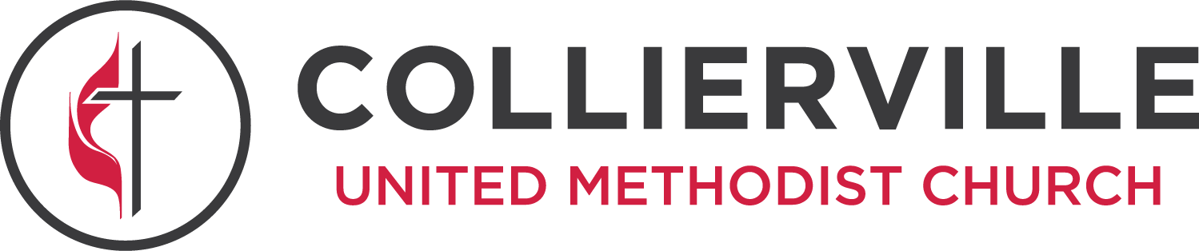

Our Core Values & Guiding Behaviors

SCRIPTURE ~ Psalm 119:105 ~ “Your word is a lamp to my feet and a light to my path.”
- I will make Scripture my foundation by reading and diving into it daily.
- I will allow Scripture to guide all my decisions and interactions with others.
- I will consistently recognize opportunities to share the Good News.
LOVE ~ Luke 10:27 ~ Jesus answered, “Love the Lord your God with all your heart and with all your soul and with all your strength and with all your mind;” and “Love your neighbor as yourself.”
- I will love God, self, and neighbor as Christ loves.
- I will reflect the Fruit of the Spirit (Galatians 5:22) in all my interactions.
- I will love God by worshipping corporately each week.
HUMILITY ~ Micah 6:8 ~ “God has shown you, O mortal, what is good. And what does the LORD require of you? To act justly and to love mercy and to walk humbly with your God.”
- I will welcome ideas, opinions, and perspectives of others.
- I will seek through daily prayer to recognize my weaknesses and will work toward being continually transformed.
- I will believe the best of others’ intentions. (I will look for the Jesus in others.)
SERVANTHOOD ~ Mark 9:35 ~ Jesus said, "Whoever wants to be first must be last of all and servant of all.”
- I will strive to serve with a spirit of self-sacrifice as Christ.
- I will strive daily to model my actions on the life of Christ.
- I will seek to serve others from pure motives.
- I will do the smallest task with great love.
MISSION ~ Matthew 28:19-20 ~ “Go therefore and make disciples of all nations, baptizing them in the name of the Father and of the Son and of the Holy Spirit, and teaching them to obey everything that I have commanded you. And remember, I am with you always, to the end of the age.”
- I will be prepared to give the reason for the HOPE that is in me.
- I will seek ways to invite others to worship.
- I will extend God’s love to the world by monthly serving through hands-on projects to the least, the last, and the lost; the hungry, the poor, the child, the widowed, those in prison and in the hospital, etc.
- I will memorize and live out the vision statement of Collierville UMC.

